**Bug Report**

**Date: 28/01/2025**

**Tested By: Vishnurag. P**

|  |  |
| --- | --- |
| **Platform** | **Browser** |
| Windows 10 | Chrome, Edge, Firefox |

|  |  |  |
| --- | --- | --- |
| **Who Detected** | **How Detected** | **Status** |
| Quality Assurance | Testing | Open |

|  |  |  |  |  |  |
| --- | --- | --- | --- | --- | --- |
| **Founder** | **Bug ID** | **Type** | **Test Case ID** | **Description** | **Steps** |
| Vishnurag. P | BUG_01 | Bug | TC_06 | Invalid Mobile  Number is  Accepted | 1. Launch the BharatGo login page 2. Enter the Invalid number in the Mobile number Input field 3. Click the “Get Started” button to check its accepting or giving an error message. |
| Vishnurag. P | BUG_02 | Bug | TC_16 | Invalid Names accepted as Store Name | 1. Click the Store name entering field 2. Give invalid name like ,”a@##%^&*+_&” or “a______ b” 3. Check it is accepting or giving a error message. |
| Vishnurag. P | BUG_03 | Bug | TC_18 | Invalid Owner Name accepted | 1. Click the Owner name entering field 2. Give Invalid User name like a single alphabet 3. Example “S” / “A” 4. Check it is accepting or giving a error message. |
| Vishnurag. P | BUG_04 | Bug | TC_29 | The Store time is accepted as blank | 1. Click the store time changing 2. Clear the existing time 3. Save the time 4. Check whether there is any error message |
| Vishnurag. P | BUG_05 | Bug | TC_30 | The Next Button in the Personalize your page of onboarding is not deactivate before making any changes | 1. Get into the Onboarding page where Logo and banner are changing 2. Click next button without make any changes 3. The button should be deactivated because there is a Skip button |
| Vishnurag. P | BUG_06 | Bug | TC_31 | The Skip button is Not visible before making any changes | 1. Get into the Onboarding page where Logo and banner are changing 2. Check the Skip button 3. It should be active and visible |

TC_16:

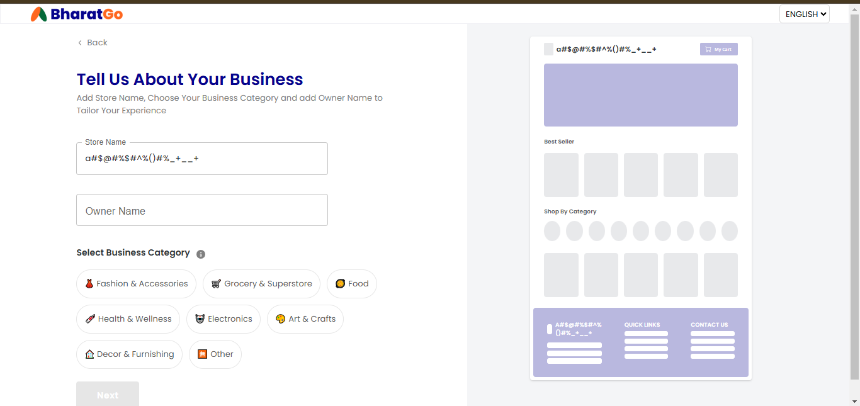

TC_18

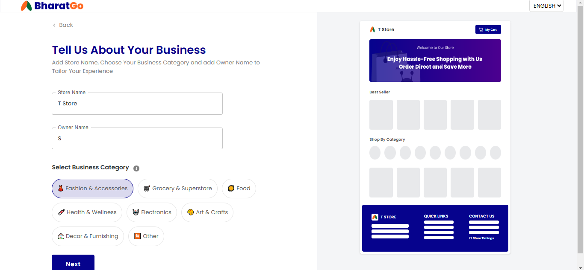

TC_29

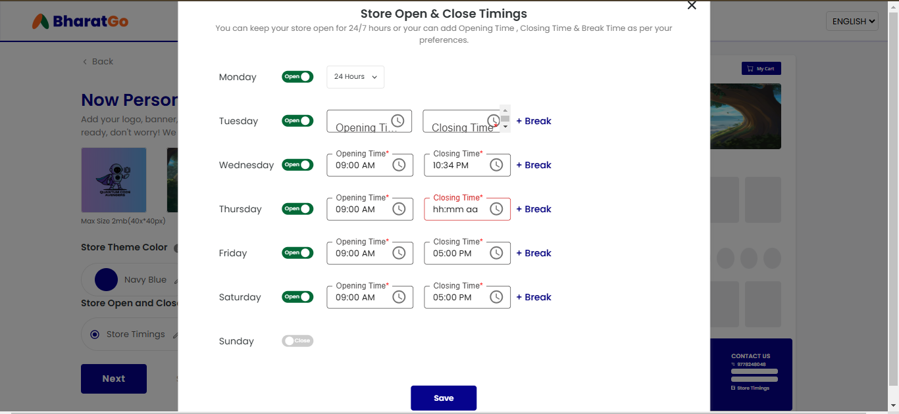

TC_31

